12/01

* theory
* research design
  + data sources
* measurement
  + independent/dependent variables
* results

11/27

* upload data sources to Google Doc
* upload code and figures to folders
  + code: <https://drive.google.com/drive/folders/1uZ6DbzwUMwzg-0CWTaRLGp9tHMLGbSZt?usp=share_link>
  + figures: <https://drive.google.com/drive/folders/1HrmUW9maeRdPN_EwppCpnNDjgLaXe7YI?usp=share_link>
* do this by Tuesday

11/22

* write-up structure
* data sources
* variables of interest
* analysis
* agnostic to model (add why)
* run a bunch of models, lowest RMSE
* maps to show patterns

11/06

sources:

* UN/IGO/autocracy: Calli
* HDI/corruption: Ray
* FDI: Yan [China FDI data](https://docs.google.com/spreadsheets/d/1u2TBnB30L5_BFte7sIo0-BDQmMBiKzd5bGmitq5NNU0/edit?usp=sharing)
* Transparency International: Danny
* resource: Jeffrey
* Trade: raphael, crystal, ryan

methods/models:

* data collection
* linear regression
* prediction
* Geospatial

2 predictive outcomes: diplomatic, economic

* Take each side, make a single predictive outcome thru all the data

In class notes 11/03

Use “New Gene Software” for our project (according to professor Joseph, this might be extremely helpful in our data collection. (used primarily for quantitative data analysis).

<https://www.newgenesoftware.org/>

11/01

theory:

* targeting resource-rich developing countries through diplomatic relations to facilitate economic development
  + Africa/South America/Middle East

independent variables:

* diplomatic
  + autocracy/“peace” stats (regime type)
  + intergovernmental
* economic
  + BRI investment
  + corruption/HDI
    - dataset: Transparency International
  + resource rich countries

dependent variables:

* diplomatic metric combining
  + UN votes
  + number of embassies/consulates per capita
  + schools (language/culture)
* economic
  + foreign direct investment (rate of growth year by year)

diplomatic predict diplomatic, economic predict economic

methods/models:

* data collection
* linear regression
* prediction
* geospatial

validity:

* data sources may not be a direct correlation (HDI, autocracy)
* hidden data/manipulated or inaccurate data
* time dependency (controlled for by selecting specific years to analyze, external events to impact)

Prof Responses

* geospatial:
  + maps will be last thing we do
  + data will be shaped as:

country, year, data (can be numeric/categorical)

* + program will know country boundaries
  + hard to overlay colors
    - must have multiple maps or combine data somehow
* research design:
  + focus on at most two outcomes
    - e.g. diplomatically/economically
  + two possibilities
    - one of these is what we care about the most (most theoretically relevant), track that one
    - factor/IRT model
      * aggregate into single measure
      * e.g. use variables to summarize economic expansion
        + foreign direct investment
        + labor exchanges/immigration
        + trade treaties/tariff barriers
  + difference in change in China’s influence
    - country/year dataset
    - can include control variables
      * border China or not
      * communist during the Cold War (history of communism?)
      * country’s GDP
      * authoritarian/democracy (similar ideology?)
      * level of corruption
      * human development index
  + figure out what our theory is, what would affect/cause China to intervene in another country
* project risks:
  + making assumptions
  + unable to measure well
  + not enough/limitations in/concerns with data
  + models may not be accurate
    - why answer we get is not the right answer
  + what are we not able to do
* UN/IGO/autocracy: Calli
* HDI/corruption: Ray
* FDI: Yan
* Transparency International: Danny
* resource: Jeffrey
* Trade: raphael, crystal

10/31

Attendance:

* Danny, Crystal, Raymond, Jeffrey, Yan, Andrew, Ryan

Types packages to run for data:

* tidyverse
* ggplot2
* base

Mid-term progress memoranda (submit individually) (mid-term exam): (10 points)

Submit a maximum 5 page Memoranda that describes your group’s progress.

| Does the Memoranda detail a research design that is justified by theory | 20% |
| --- | --- |
| Does the Memoranda identify key dependent and independent variables | 20% |
| Does the Memoranda discuss the data sources the team intends to use to measure the main variables (including URLs) | 20% |
| Does the Memoranda discuss Estimation strategy and models the team intends to use | 20% |
| Does the Memoranda discuss potential threats to validity or other project risks that the team will need to address | 20% |

Things to ask tomorrow

* Estimation strategy/models
* Research design
* What does project risks mean

Midterm Progress Memo Items:

* Key dependent and independent variables
  + Independent
    - military: arms deals
    - political/IGO: UN votes
    - economic/logistic: Belt and Road Initiative
    - cultural lens: schools/tourism (?)
  + Dependent (overall, countries where soft power spreads to next)
    - military: arms deals
      * countries accepting military aid/sales from China
    - political/IGO: UN votes
      * countries voting with China on similar political/cultural issues
    - economic/logistic: Belt and Road Initiative
      * countries sustaining economic relations with China long-term
    - cultural lens: schools/tourism (?)
      * over time, which countries have had the highest rate of flow of people to and from China
      * potentially compare and contrast
* Data sources
  + military: arms deals
    - <https://www.sipri.org/databases/armstransfers>
  + political/IGO: UN votes
    - <https://dataverse.harvard.edu/dataset.xhtml?persistentId=doi:10.7910/DVN/LEJUQZ>
    - Precompiled and open source NEEDS CITATION
  + economic/logistic: Belt and Road Initiative
    - <https://www.cfr.org/article/belt-and-road-tracker>
    - <https://datacatalog.worldbank.org/search/dataset/0038706/Belt-and-Road-Initiative-Trade-Costs-Database>
  + education
    - <https://edunomix.com/2019/07/21/chinas-global-education-footprint/>
* Estimation strategy and models
* Potential threats to validity/Project risks
  + Data sources might not be a direct correlation to soft power, especially for bigger countries that rely on each other economically but don’t necessarily get as influenced as soft power.
  + Some countries might have hidden data related to security (ex: arms deals, economy)
  + Time-dependence of data might affect results; different events might confound data and make future predictions inaccurate because they are based on data that should not be extrapolated
    - Be cognizant of time the data starts
    - controlled for by selecting specific years to analyze, external events to impact
* Research design
  + Research and design a model
  + Figure out tomorrow
  + Justified by theory?

10/27

* Mid progress report (due 11/3)
* 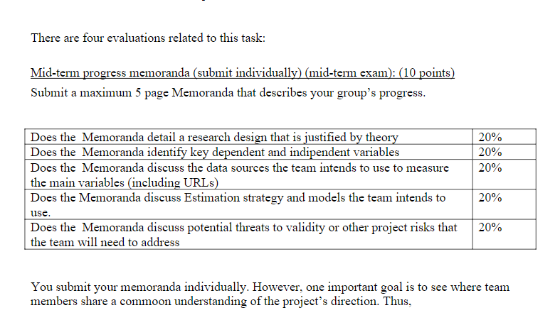
* Summary Report: <https://canvas.ucsd.edu/groups/103204/discussion_topics/524119>
* Collect data on China’s expansion along several dimensions (e.g. Confucian institutes, Foreign investment).
  + List of Countries with Confucian Institutions:
    - <https://www.digmandarin.com/confucius-institutes-around-the-world.html>
  + Chinese Foreign Investment:
    - <https://tradingeconomics.com/china/foreign-direct-investment>
  + African/China contracts
    - <http://www.sais-cari.org/data-chinese-contracts-in-africa>
    - <http://www.sais-cari.org/data>
  + Arms Deals Data
    - <https://tradingeconomics.com/china/weapons-sales#:~:text=Weapons%20Sales%20in%20China%20averaged,updated%20on%20October%20of%202022>.

Belt and Road initiative (Geospatial Map)

<https://www.cfr.org/article/belt-and-road-tracker>

Transparency International:

* <https://www.transparency.org/en/cpi/2021?gclid=Cj0KCQjwqoibBhDUARIsAH2OpWi5lozVUlBIYtLL6NwG47XaZ-uKm6UGI3yz03ns8tQogmq1lBtssWMaArKDEALw_wcB>
* List of Chinese Embassies:
* https://www.fmprc.gov.cn/mfa_eng/wjb_663304/zwjg_665342/2490_665344/
* Natural Resources Data:
* https://data.worldbank.org/indicator/NY.GDP.TOTL.RT.ZS
* China has expanded its soft power. Collect data on China’s expansion along several

dimensions (e.g. Confucian institutes, Foreign investment). Visualize it in a map. Then, develop a predictive model to explain where China will expand next.

Information sources

* <https://en.wikipedia.org/wiki/Soft_power_of_China>
* <https://www.pewresearch.org/global/2014/07/14/chapter-2-chinas-image/>

Metrics we can use to measure

* Trade balance - Raphael/Andrew
* Arms sales - Yan
  + <https://www.sipri.org/databases/armstransfers>
* Confucian institutes/cultural: Crystal
  + <https://www.aspistrategist.org.au/the-role-of-soft-power-in-chinas-influence-in-the-pacific-islands/>
  + Soft power report in general: <https://www.britishcouncil.org/sites/default/files/3418_bc_edinburgh_university_soft_power_report_03b.pdf>
    - Has a lot of data/charts inside, but need to sort out which ones pertain to china specifically
* UN Votes: Foreign relations - Calli
  + https://cddrl.fsi.stanford.edu/research/autocracies_of_the_world_dataset
* Foreign Direct investment - Yan

Outbound Chinese FDI: https://www.aei.org/china-global-investment-tracker/

* International views of China
  + <https://www.pewresearch.org/global/2014/07/14/chapter-2-chinas-image/>

Other sources

* https://datacatalog.worldbank.org/search/dataset/0037712/World-Development-Indicators
* https://datacatalog.worldbank.org/search?q=&fq=(geographical_extent%2Fcoverage%2Fany(geo:geo%2Fname%20eq%20%27Macao%20SAR,%20China%27))

https://data.worldbank.org/indicator/NY.GDP.TOTL.RT.ZS